

**REPUBLIC OF CAMEROON**

**Peace-Work-Fatherland**

**MINISTER OF HIGHER EDUCATION**

**FACULTY OF ENGINEERING**

**AND TECHNOLOGY**

**REPUBLIQUE DU CAMEROON**

**PAIX-Travail-Patrie**

**MINISTRE DE L’ENSEIGNEMENT SUPERIEUR**

**FACULTE D’INGINERIE**

**ET TECHGNOLOGIE**

**CEF440**

**INTERNET AND MOBILE PROGRAMMING**

**DESIGN OF TAXI APP**

**Presented by:**

**HEUYA NDJANSEB KEVIN KENNEDY FE20A049**

**Tendo Kris Diogwi FE20A114**

**LEKEAKA DELAND ACHANANK Fe20A056**

**MAFONGANG SOUPGUI DENISE VANELLA FE20A061**

**YUVEN BRENDARD WIYFOFE FE20A124**

**INSTRUCTOR**: **Dr. NKEMENI VALERY**

**March 2023**

**CONTENT:**

**→ Use Case diagram**

**→ Activity Diagram**

**→ Data Flow Diagram**

**→ Class Diagram**

**→ Sequence Diagram**

**1. USE CASA DIAGRAM**

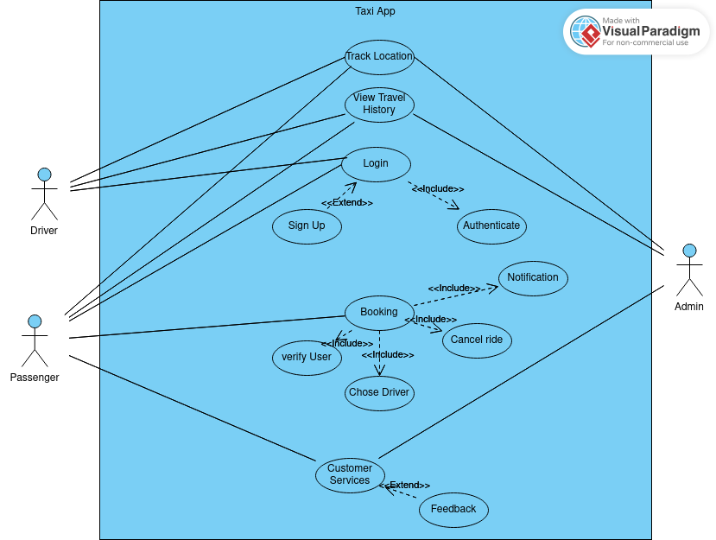

**Description:**

**BOOKING:** This Use case allow the passenger to book for a ride. When the a passenger book for a ride, he/she is first verified. After the system have verify the passenger account, he/she is then can then design on choosing any available driver fo the ride. When the driver is choosing, a notification is directly sent to him and can decide on weather to confirm or cancel the ride. After the driver have taken a decision, another notification is sent to the passenger.

**VIEW TRAVEL HISTORY:**  This use case allow the passenger to view the travel history of the driver to know if the driver have already gone to his/her destination. This will help some passenger to have more trust in the driver and the application.

**TRACKING:**  This use case make sure taxi drivers can easily locate passengers or the users to track their destination and direction. This make sure the driver can find the best and shortest road to arrive at the destination.

This also allow the system to track all the taxi driver when the are using the application.

**LOGIN:** This use case allow the users to login to their account. When a user want to login to his/her, the user will first authenticate by inputting his/her password and a username. If both correspond with that of the system, then the user is allow to access the account. In case the user does not have an account, he/she can create one either as customer or driver.

**CUSTOMER SERVICE:** This use case allow all users of the platform to sick for assistance on any challenges they are facing while using the app. This also allow users to give feedback on their experience while using the app in order to improve the app.

**2. DATA FLOW DIAGRAM**

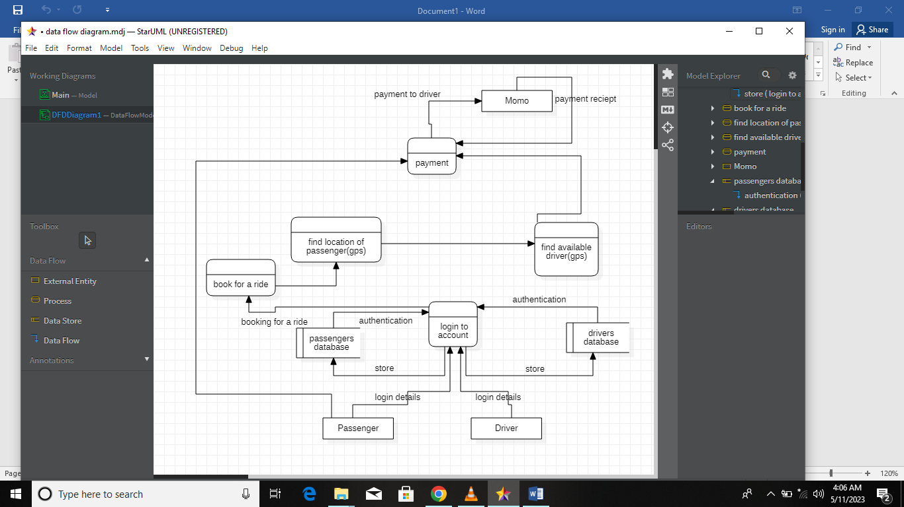

**Introduction:** The passengers positioning system is designed to help passengers book vehicles with ease and automatically locate them using GPS. The system is integrated with MOMO (MTN Mobile Money) payment system, allowing passengers to pay for transportation with MOMO. The system also enables drivers to register and login, and they can receive payment via MOMO.

Data Flow Diagram: The data flow diagram (DFD) of the passenger positioning system consists of four main components: passengers, drivers, GPS system, and the MOMO payment system.

1. **Passenger Component:** The passenger component includes all passenger-related functions such as registration, login, booking, and payment. A passenger registers and logs in to access the system. After logging in, the passenger can book a driver by entering their location, destination, and payment details. The booking information is then sent to the GPS system, where it is used to locate the passenger. The passenger can pay for transportation using the MOMO payment system.
2. **Driver Component:** The driver component includes all driver-related functions such as registration, login, and location. A driver registers and logs in to access the system. After logging in, the driver's location is automatically tracked using GPS, which makes it easy for passengers to locate them. Once a driver is booked, they receive a notification, and they can accept or decline the booking. After the trip, the driver receives payment via MOMO.
3. **GPS Component:** The GPS component is responsible for tracking the location of both the passengers and the drivers. It receives information from both the passenger and driver components and uses it to locate the parties involved. The GPS component updates the system in real-time, making it easy for both the passengers and drivers to track one another.
4. **MOMO Payment System:** The MOMO payment system integration allows passengers to pay for transportation with ease. After booking a driver, the passenger enters their payment details, and the payment is processed using MOMO. The driver receives their payment via MOMO after the trip is complete.

**Conclusion:** The passengers positioning system is designed to provide an easy and efficient way for passengers to book and locate drivers. The system is integrated with GPS, which enables automatic location tracking, and MOMO payment system, which makes payments easy. The data flow diagram of the system shows how the passengers, drivers, GPS, and MOMO payment systems interact to form a functional and reliable system.

**3. SEQUENCE DIAGRAM**

Assuming the hardware is part of the system.

**I. Sequence diagram of Booking Use Case:**

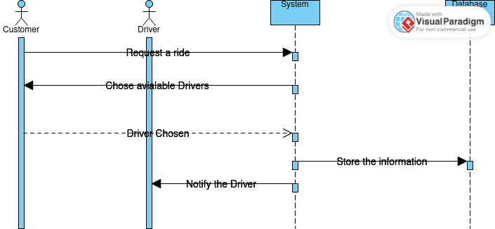

**II. Sequence diagram of Log In Use Case:**

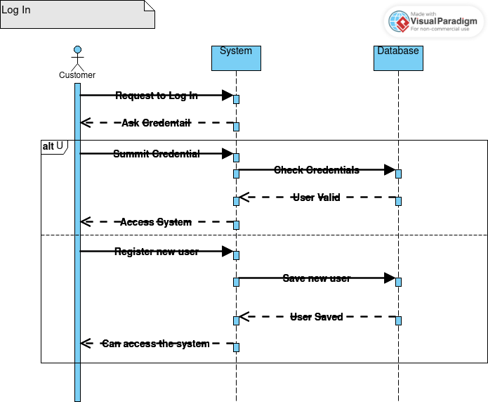

**III. Sequence diagram of Customer Services Use Case:**

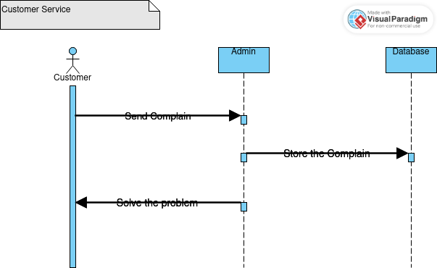

4. ACTIVITY DIAGRAM

Assuming the hardware is part of the system.

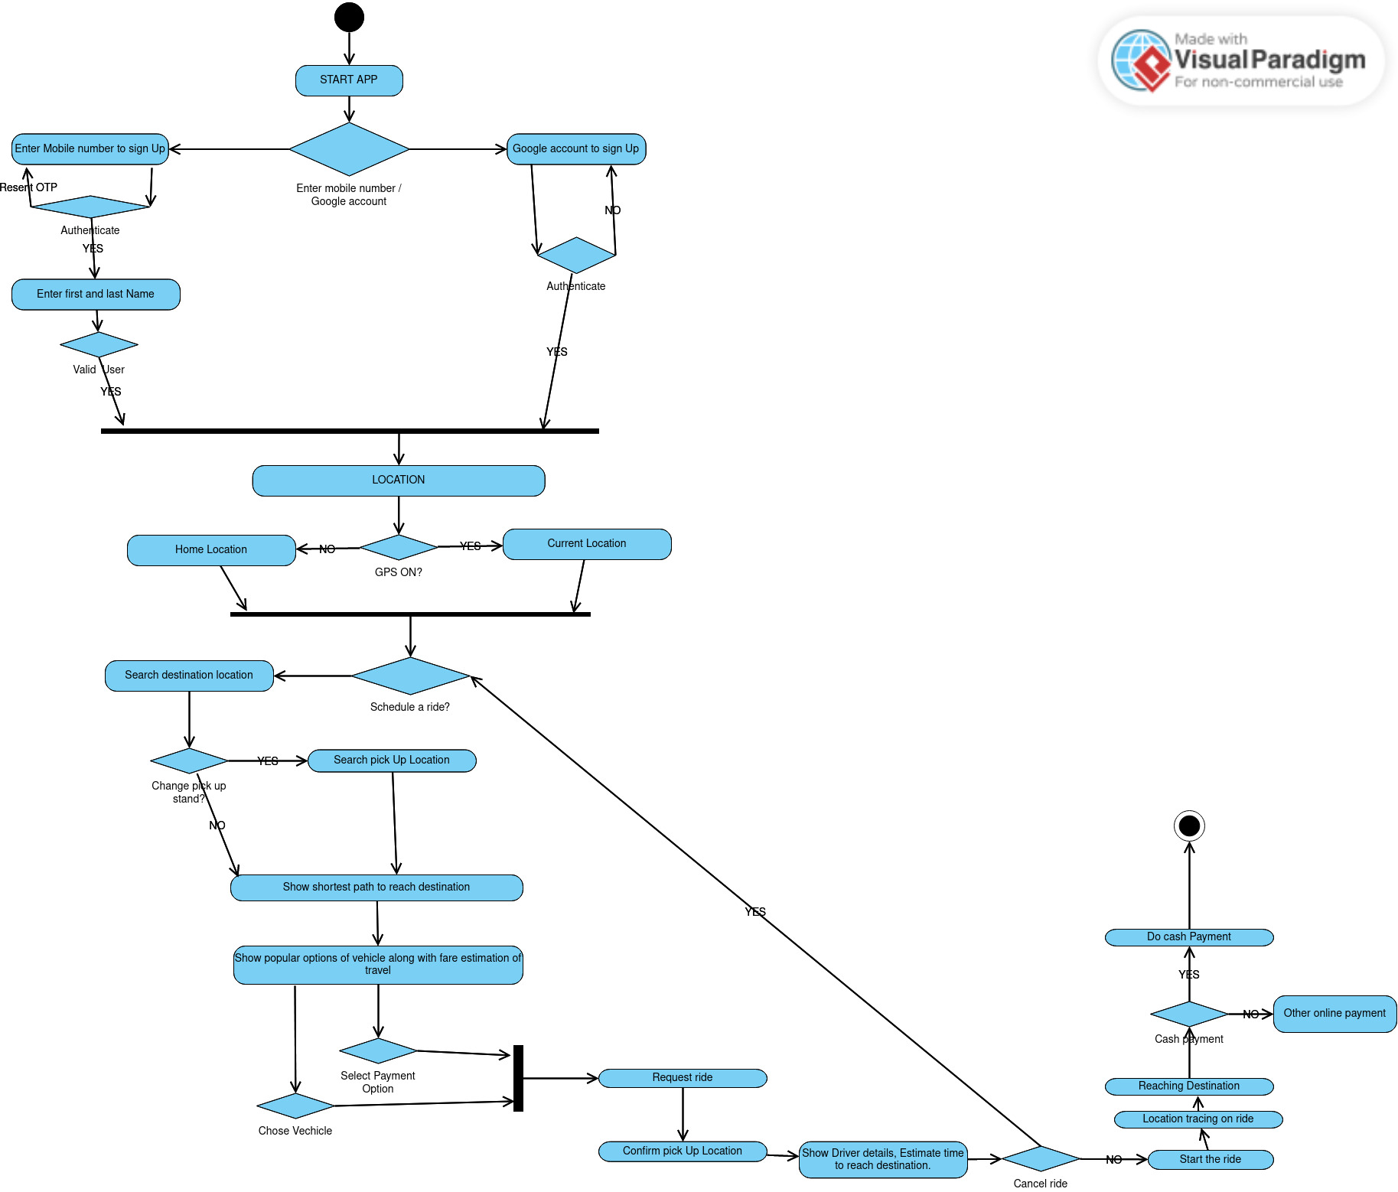

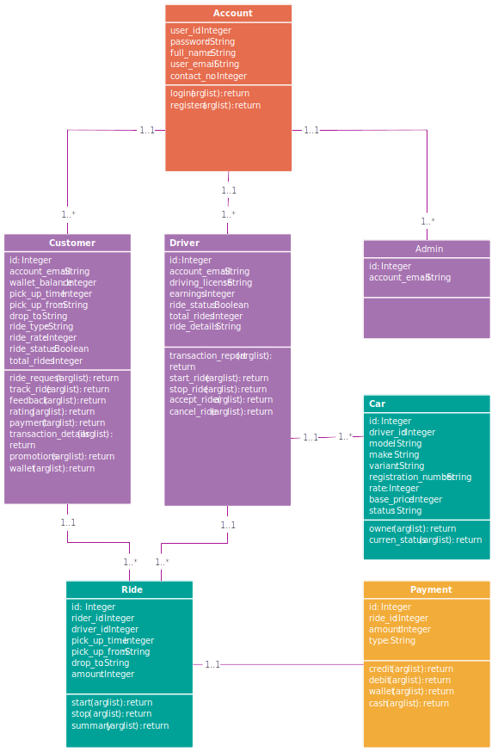 **5. CLASS DIAGRAM**